Tuesday
Subtraction by counting back
Warm up
- Collect pairs of socks from around the house and practise counting in 2s: 2, 4, 6, 8, 10, 12, 14, 16, 18, 20.
- Count how many spoons you have in the drawer. Take away 1 at a time to count back.
Activities

Re-watch the subtraction by counting back video.

Make a line of ten objects (toys, apples etc.)

Roll a dice or pick a number card then take away that number from 10.

For example, roll 5. Write 10 – 5 = ? Use the objects the ‘take away’ by counting back to find the answer. Repeat with different examples. You could also subtract from 20 objects if confident.
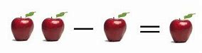

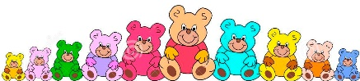
10 – 3 = ?

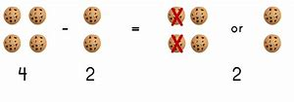

There are also some useful resources here:
https://www.twinkl.co.uk/resource/t-n-2545272-counting-back-to-subtract-differentiated-activity-sheets

