Thursday
Positional Language
Warm up
- Count forwards and backwards from different starting numbers.
- Place numbers in a bowl or jar Time how quickly they can take out all of the numbers and put them in order!
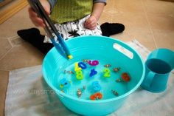
Activities
Introduce the positional language you are learning today: on, in, under, below, outside, inside, next to, on top of and between. You could demonstrate this using a table e.g. Mummy is under the table. Where is mummy now?

Ask your child to find a special toy. Give instructions for where to place the toy using this key language e.g. Put teddy in front of the washing machine. Put teddy underneath the chair. Put teddy on top of the sofa. Put teddy behind the door. Put teddy next to the curtain. See if your child can follow the instructions!
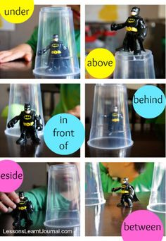

Repeat with different examples and then swap so that the child is the teacher, telling you where to place the toy using their positional language. They can use their best bossy teacher voice! Please take photos to share on evidence me.

You could also try these activities: https://www.twinkl.co.uk/resource/au-n-541-whats-the-position-cut-and-paste-activity-sheet
https://www.twinkl.co.uk/resource/t-l-974-alien-positional-language-worksheets

