Tuesday
Missing Numbers
Warm up
- Running race! Get as many members of the family as possible to join in. Each person runs a set distance e.g. from one end of the street to the other end. Together count (steady, regular seconds) to time how long this takes (you could also use a stopwatch). Record everyone’s score. Who is the winner? Can you improve your time?
Activities
Make or print a set of number cards to 20. Practise ordering numbers from 0-10. Count forwards and backwards and say the number names.
Next, order numbers up to 20. Count and practise quick number recognition e.g. Can you find 17?
Ask your child to close their eyes whilst you remove one of the numbers. Open eyes and see if they can tell you which number is missing. Repeat with different missing numbers and try removing more than one. Make it into a fun game! You could also swap so they are the teacher and you have to guess!
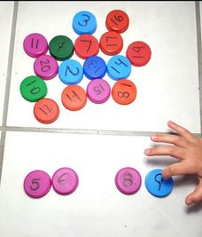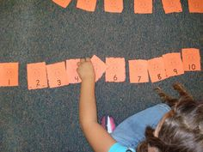

Emphasise using one more/one less to help number understanding e.g. I know that the missing number is 10 because it is one more than 9 and one less than 11. Please take photos to share on evidence me.
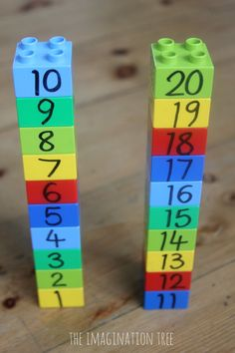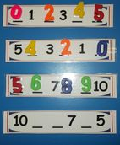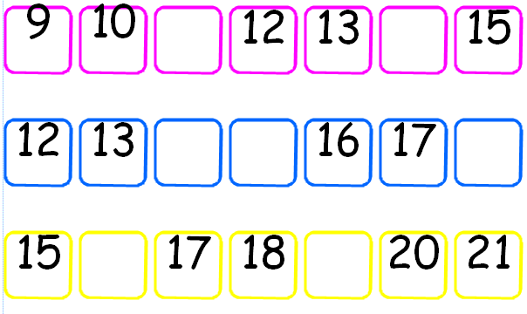

*You could also try this missing number worksheet https://www.twinkl.co.uk/resource/t-n-7069-superhero-missing-number-1-to-20-activity or the missing numbers documents attached below.

