Friday
More or Less?
Warm up
- Throw a ball or small soft object back and forth whilst counting in ones.
- Next practise counting in twos.
- Clap and count in 2s and 10s.

Activities

Find a selection of small evenly sized objects for today’s ‘more or less’ challenge. Lego is great but you could use anything: bananas, leaves, pencils etc.

Place these in a pile on the floor and randomly split the pile into two uneven groups. Can you tell me which pile has more? Which has less?

See if your child can estimate ‘guess’ how many are in each group and then check by counting.

Repeat with different examples (splitting the pile into different groups and extending to 3 or 4 groups if confident). Emphasise language of more (the numbers are higher in value) and less (numbers are lower in value).
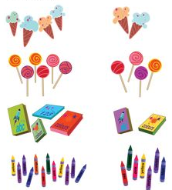

Play the more or less card game. Count to 3 and both take a card from the pile at the same time. Whoever has the highest value number gets a point!

