Subtraction by counting back
Warm up
- Use a big piece of paper to write large numbers to 20. Ask your child to close their eyes and cover one of the numbers with a cup/object. Which is missing?
- Clap and count numbers both forwards and backwards.
Activities

Explain that today we are going to be going backwards! Find a large space and practise walking/jumping/hopping backwards whilst counting back from 20. You could draw a large number line to help.

Explain that when we subtract (take away) the answer will be smaller than the first number (we end up with less!) You could show this with a plate of treats e.g. “Now mummy is going to take away 3 of your biscuits” to emphasise that we end up with fewer than the starting amount.

Watch the subtraction by counting back video.
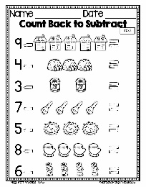
Practise your own subtraction problems by counting back with small practical resources such as buttons, lego, coins etc.
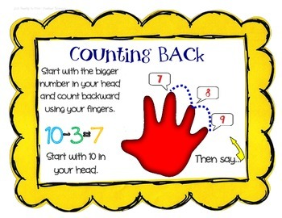
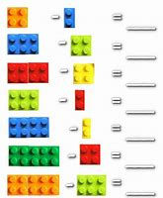
You can also show subtraction on your fingers.

