Thursday
Adding by counting on a number line
Warm up
- Play a ‘show me…’ number game on fingers e.g. Show me 4! Show me 3!
- Do hopping and star jumps counting from 0-30.
- Play splat the number using https://www.topmarks.co.uk/learning-to-count/paint-the-squares
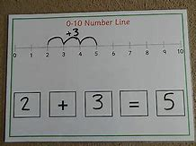
Activities
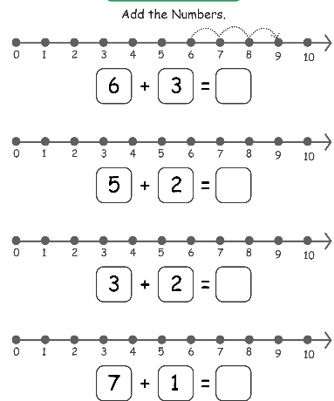
Re-watch the video tutorial explaining how to add by counting on using a number line.

Try to solve these addition problems using a number line:
3 + 3 =
5 + 3 =
4 + 2 =
6 + 1 =
7 + 4 =
8 + 5 =
9 + 2 =

(More challenging)
10 + 5 =
11 + 2 =
13 + 4 =
14 + 2 =
11 + 9 =
16 + 3 =
12 + 6 =

Practise by jumping along the number line to add and solve the problems. You can record the answers or do it practically and ‘saying the number sentence’.
More activities here: https://www.twinkl.co.uk/resource/t-n-3016-addition-to-20-with-a-number-line-activity-sheet

