Wednesday
Adding by counting on a number line
Warm up
- Play a game of counting objects in the house e.g. How many teddies do you have? How many chairs are at the table? How many toothbrushes are in the bathroom? How many books are on the shelf?
- Practise ordering numbers from smallest to highest value https://www.topmarks.co.uk/ordering-and-sequencing/caterpillar-ordering
Activities
Watch the video tutorial explaining how to add by counting on using a number line.

If you can, draw a big number line from 0-20 using chalk. Otherwise, you could use paper or print a small version here https://www.sparklebox.co.uk/maths/counting/number-lines/number-lines.html
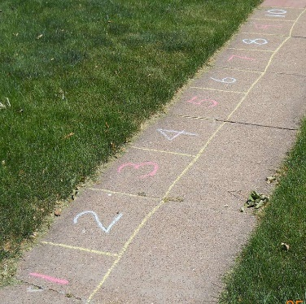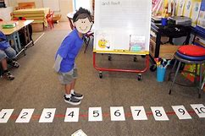
Practise ‘jumping’ along the number line to solve addition problems.

For example, 5 + 2 = ?
Start on 5 and jump 2 spaces forwards. What is the answer?
Repeat with different examples.



