Tuesday
Time
Warm up
- Order number cards from 1-12 to make a clock circle!
- Sing the ‘what’s the time?’ song. https://www.youtube.com/watch?v=RBvmO7NgUp0
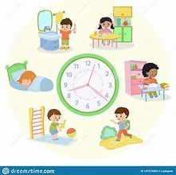
Activities

Repeat the time activities from yesterday practising using a clock to find different times.

You could make a daily timetable and discuss what times you do different activities e.g. wake up at 8 o’clock, lunch at 12 o’clock.
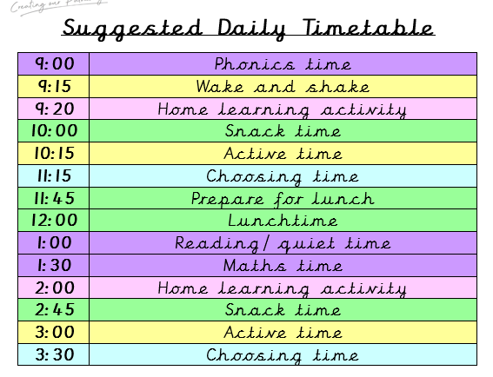
Make a colourful and fun watch or clock using a paper plate or card using the ideas below:
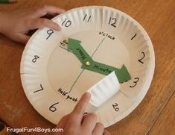
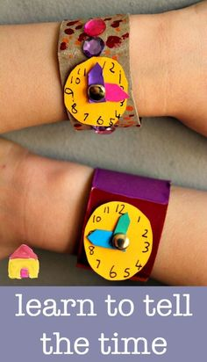

*Please just focus on o’clock and half past. They do not need to know quarter past/to yet!

There is also an easy printable template here: https://www.twinkl.co.uk/resource/t-n-5481-make-a-clock-face-activity

Also a useful game: https://www.twinkl.co.uk/resource/t-n-3081-write-the-time-o
And powerpoint https://www.twinkl.co.uk/resource/t-n-7132-telling-the-time-powerpoint

