Wednesday
Money
Warm up
- Count to 100 workout song
https://youtu.be/0TgLtF3PMOc
- Coin sorting game https://www.topmarks.co.uk/money/coins-game
Activities

Talk to your child about ‘money’. What is it for? How do we earn it? See if your child can tell you what they already know and name any of the coins.
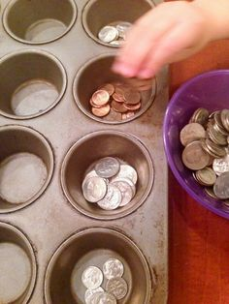
Show a selection of coins (or print here if easier https://www.sparklebox.co.uk/thumbs836-840/sb838prev.html or https://www.twinkl.co.uk/resource/t-n-1354-new-british-coins-strips)
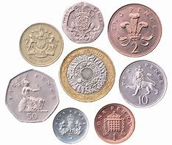
Model/show your child how to find 1p, 2p, 5p, 10p, 20p, 50p and £1. Look for the numbers on the coins and discuss colour/size/shape.
See if you can sort coins into different piles or groups.

Next, use a box or cup as a money pot. Place a selection of 1p coins inside. Can you estimate how many coins there are? Can you check by counting?
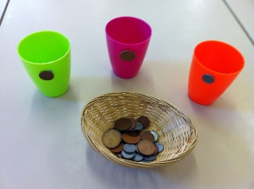
Repeat with different examples e.g. I have 2p, 4p, 10p etc.
If confident, move on to counting in 2s using 2p coins, or using 2p and 1p coins together.


