Friday
Estimating
Warm up
- Play a game of ‘Number splat’. Place number cards on a table or stick to a wall. Call out a number and race to ‘splat’ the number.
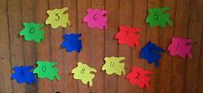
- Watch the number bonds astronauts song https://www.youtube.com/watch?v=YdPA2YHIdqU
Activities
Play ‘more or fewer?’. Use objects eg. Biscuits and place a different number on two plates. Can you tell me which has more biscuits than the other plate? Which has fewer?
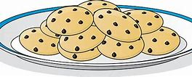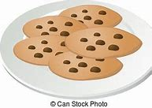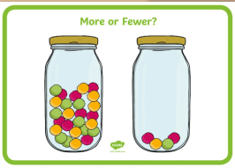
See if your child can see which plate has more/less before they check by counting.
Explain that estimating is a ‘sensible guess’. We estimate the number of objects and then check by counting.

Practise estimating how many objects are in a jar/bowl/cup. You could use pasta, lego or anything else small and evenly sized! You could prompt by asking ‘do you think there are more than 5? 10? 20?’ ‘How do you know?’ Check by counting out the objects, counting each one carefully and writing down the number.


