Wednesday
Subtraction on a number line
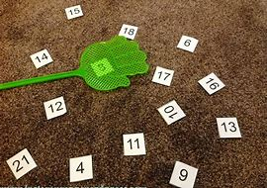
Warm up
- Count to 100 workout song
https://youtu.be/0TgLtF3PMOc
- Play splat the number using numbers to 20 or beyond.
Activities

Watch the subtraction on a number line video.

Explain that this is like the take away problem solving we did yesterday, but using the number line instead of objects.
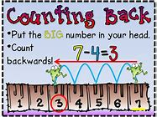

This video is also useful: https://www.youtube.com/watch?v=CNpJWC52yrk

Make or print a number line to 20. You could even use masking tape along the table!
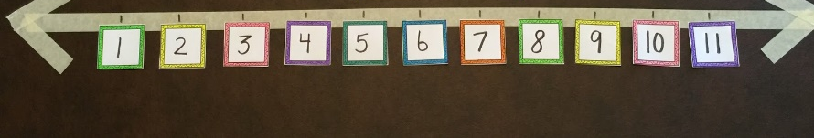
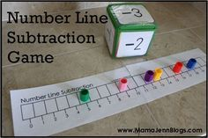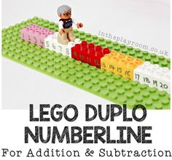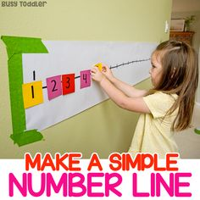
Ask your child to choose a subtraction buddy’ such as a teddy or small toy. This will be their object to ‘jump back’ along the number line.

Start with subtraction from 10 and move on to 20.

You could write subtraction problems on paper and place in a bowl to take out and solve together.

You could also try these interactive games:
https://www.topmarks.co.uk/Flash.aspx?f=Subtractdifference
https://www.sheppardsoftware.com/mathgames/earlymath/FS_NumberLine_minus.htm

