Wednesday
Missing Numbers
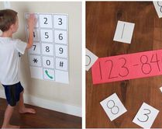
Warm up
- Telephone numbers game! Write pretend numbers for characters e.g. Superman, Spiderman, Peter Rabbit.
- Use an old phone or draw one and pretend to ‘key in the number’ to talk to these exciting people! It is also useful to remind your child how to call 999 in case of emergency.
- Practise the Count to 100 workout song
https://youtu.be/0TgLtF3PMOc

Activities
Play the ‘missing numbers’ game. Use a 1-50 square or 1-20 depending on number confidence. Practise counting forwards and backwards, as well as counting in twos (2, 4, 6, 8, 10) and tens (10, 20, 30, 40, 50). Find a small counter/stone/button and hide one of the numbers. Can they tell you which number is missing? Repeat with multiple hidden numbers and challenge your child to say and write the hidden numbers. Play a few games until confident. Please take photos to share on evidence me.
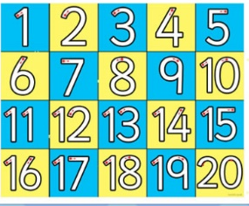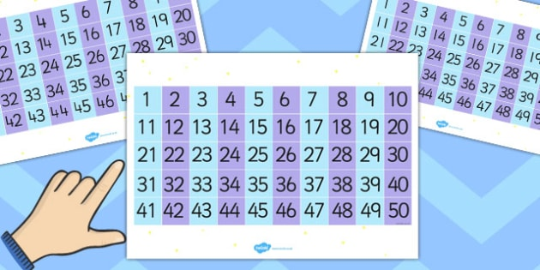

You could also practise making 2 digit numbers by turning over 2 cards at a time and then finding the number on the grid.

