Tuesday
Counting in twos
Warm up
- Find a magazine or newspaper and race to find all the numbers.
- Watch the Terrible Twos Number blocks video.
https://www.bbc.co.uk/iplayer/episode/b08dmhm6/numberblocks-series-1-the-terrible-twos
Activities
- Repeat yesterday’s counting in twos using objects challenge.
- Write the numbers 2, 4, 6, 8 and 10 on a card/small piece of paper. Jumble these up and challenge your child to put them in order.
- Now, find 10 more objects to extend your number line to 20.
- Practise counting on from 10, 12, 14, 16, 18, 20.
- You could use a number line and jump forwards, skipping the odd numbers and counting in twos.
- Use the video to help: https://www.youtube.com/watch?time_continue=23&v=bpr1RXYzHC0&feature=emb_logo
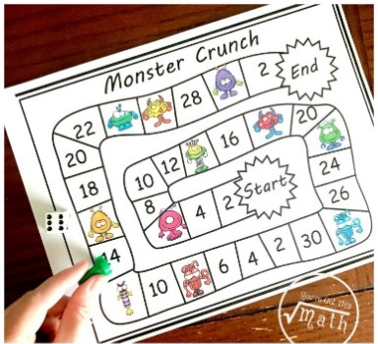
- Play the monster crunch game by making your own board or printing one out below.
*You could also try this activity:


