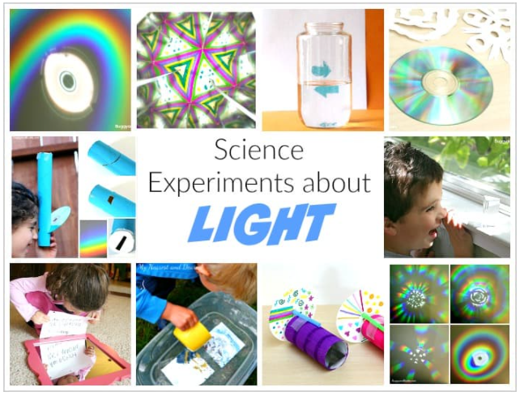

How to Make a Homemade Spectroscope

Materials for Homemade Spectroscope
- Empty paper towel roll
- Craft knife and/or scissors
- Blank or old CD
- Pencil
- Small piece of cardboard or cardstock
- Tape
- Paint (optional)

Making a Homemade Spectroscope
1. If you’ll be painting your paper towel roll, you’ll want to do that first and let it dry. (This step isn’t necessary, but it’s hard for us to pass up an opportunity to paint something!)
2. Use a craft knife (an adult should do this) to cut a thin slit at a 45° angle toward the bottom of the cardboard tube.
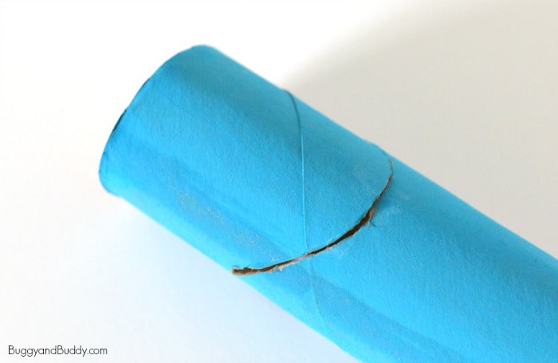
3. Directly across from the slit, make a small peephole or viewing hole using your craft knife (another step for an adult).
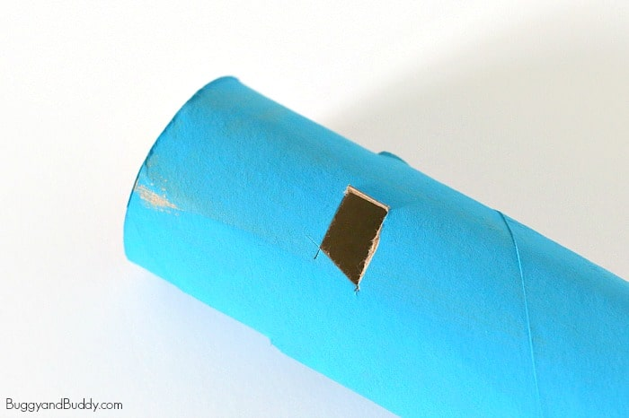

4. Trace one end of your paper towel roll onto your small scrap of cardboard or cardstock. Cut it out.
5. Cut a straight slit right across the centre of your cardboard circle.
6. Tape the circle to the top of your spectroscope.
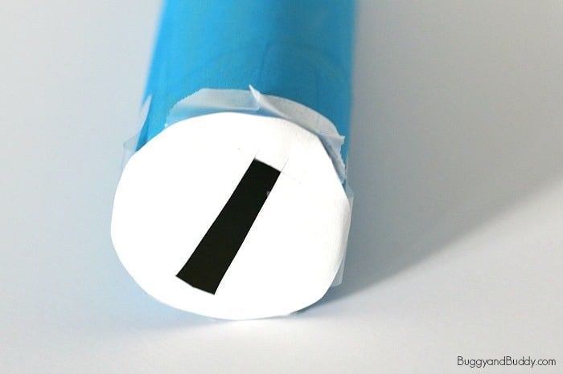
7. Insert the CD into your 45° angled slit with the shiny side facing up.
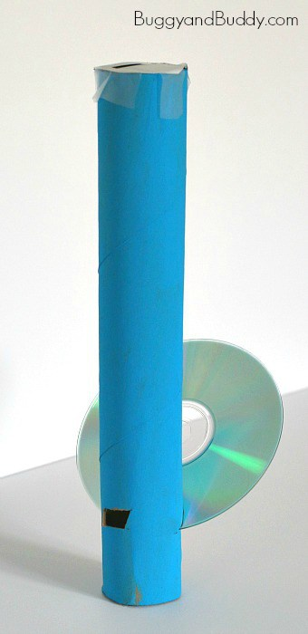

Using the Homemade Spectroscope
Start by taking your spectroscope outside. Point the top slit up at the sky (NOT directly at the sun). Look through the peephole. You will see a rainbow inside!
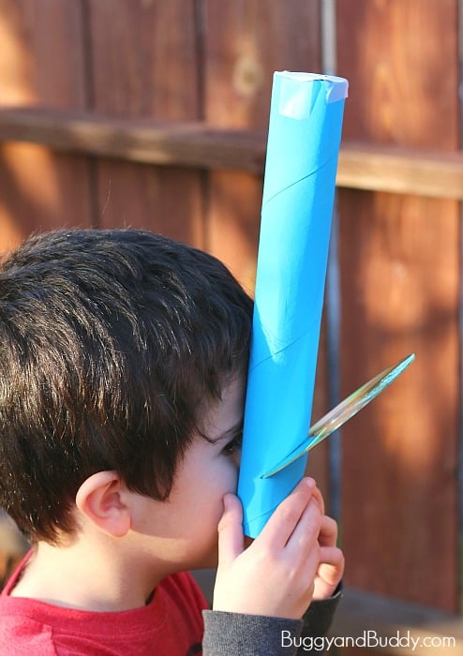
Now try your spectroscope with other light sources like fluorescent light, neon light and candle light. Compare what you see!

What’s going on?
A CD is a mirrored surface with spiral tracks or pits. These tracks are evenly spaced and diffract light (separating the colours). Because the CD’s surface is mirrored, the light is reflected to your eye.

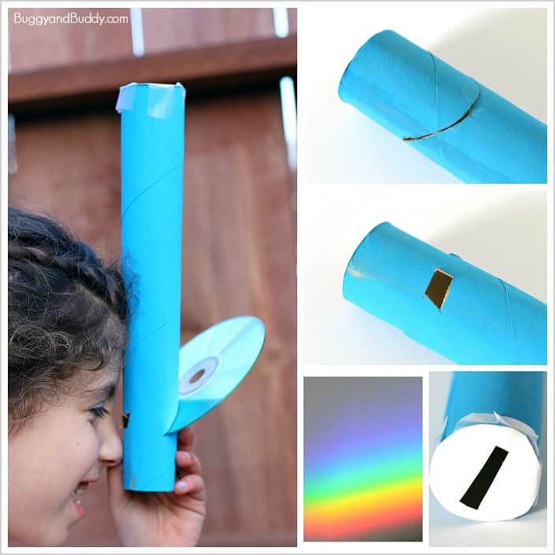

HOW TO MAKE A SUNLIGHT BOX
You’ll need a big box, plastic water bottles, duct tape, scissors, and kids of course! Optional: Paint, Paintbrushes, Food Colouring, Bleach, Foil, Cups that fit over bottles.
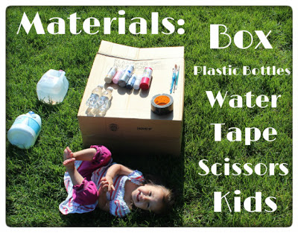

STEP 1: LET THE KIDS PAINT THE BOX!
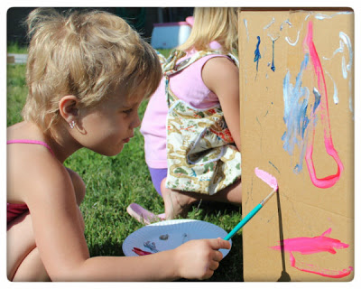

STEP 2: FILL THE BOTTLES WITH WATER.
For more fun add food colouring to some of the bottles. I recommend regular sized bottles; around 16oz. Mine were a little small. (If you are going to keep them for a while then you can put bleach in them, but I would skip it.)
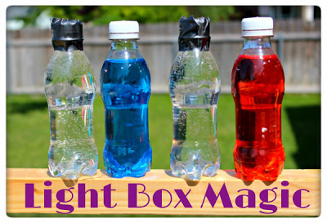

STEP 3: TRACE
Trace the bottom of the bottles on the top of the box and cut holes. Put tinfoil on the top of the box to help the light reflect into the bottles.
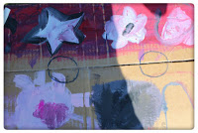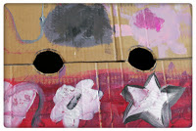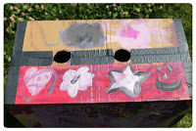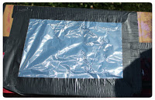

STEP 4: MAKE A VIEWING WINDOW
Cut a hole in the side of the box to look inside. I recommend cutting a smaller window or just eye holes.
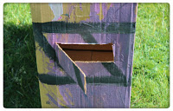

STEP 5: LET THE EXPERIMENTING BEGIN!
Push bottles into holes and have the children take turns looking in the viewing window. My daughter Audrey put her hands over the bottles to create a “light show” and I brought some cups out to make it easier.
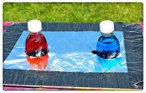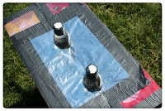
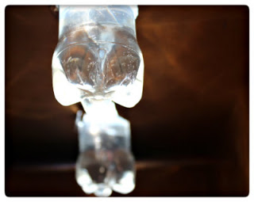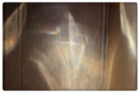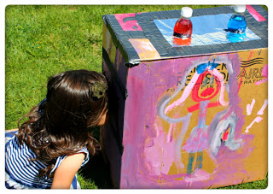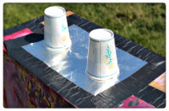

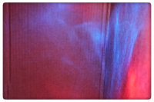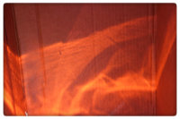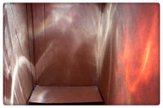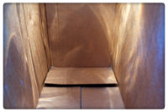

THE SCIENCE BEHIND IT:
When light from the sun hits a solid object, like the cup, it is absorbed. When light hits the water in the bottle, it bends in all different directions. It bends because the water makes the light slow down. This is called refraction. The water makes the light spread out in the box. I also gave the example of being by the pool. I told the kids we have to wear lots of sunscreen by the pool because the water makes the light spread out and we can burn easily from the light. You can also show the children what the light does when there are just holes in the top of the box and no water bottle.

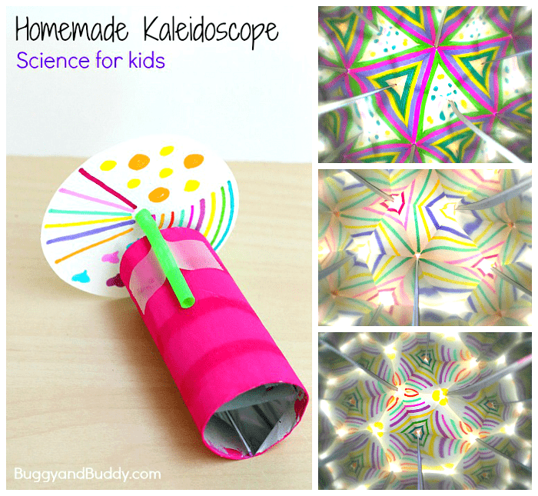
How to Make a Kaleidoscope

Materials for Homemade Kaleidoscope
- Empty toilet paper roll
- Mylar sheets (thicker sheets, not rolls of thin paper) or mirrored sheets
- Scissors and/or paper cutter (This is the paper cutter I keep at home. It’s come in super handy!)
- Tape
- White cardstock
- Bendy straw
- Markers, stickers, or other materials for decorating your spinning circle
- Optional: Paint for decorating your cardboard tube

Directions for Homemade Kaleidoscope
1. If you are planning on painting your cardboard tube, do that first. Set it aside to dry.
2. Next, you’ll need to cut your mylar sheets or mirrored sheets into three equal strips. You’ll want the size to be just right so the finished kaleidoscope insert fits snuggly in your cardboard tube and won’t fall out.
We cut our mylar into strips that measured 9.7cm x 3.5 cm.
3. Line up your mylar strips, leave a tiny space between each one. (Place the shiniest/least scratched sides face down.) Tape them together over the spaces.
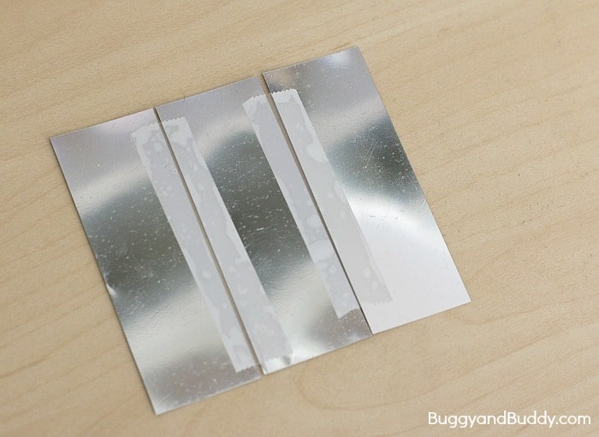
4. Fold the taped mylar into a triangular prism and tape along the top to hold in place.
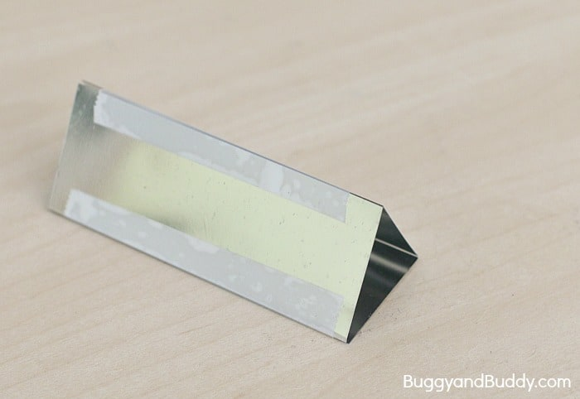
5. This should fit snuggly inside your cardboard tube.
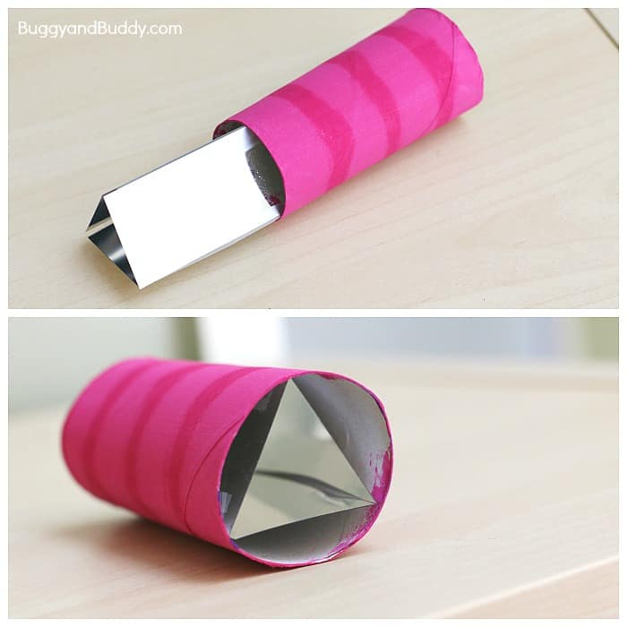
6. Cut off the bendy end of a flexible straw.
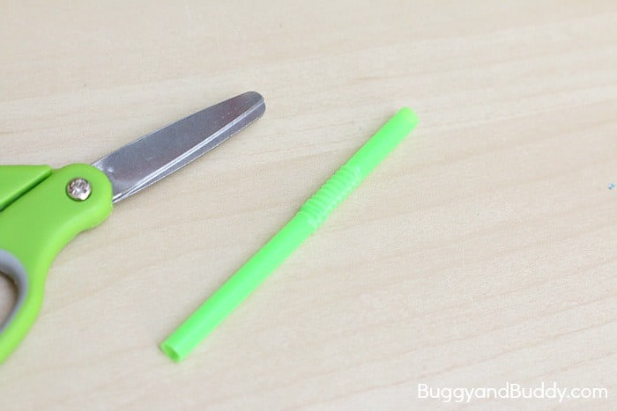
7. Tape it along the top of your tube with the flexible part of the straw hanging over the edge.
8. Cut out 3 circles from cardstock. Ours measured 3.75 inches in diameter.
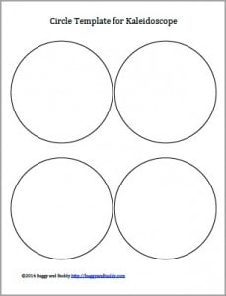
9. Poke a hole in the centre of your circle. (I used a sharp pencil.)
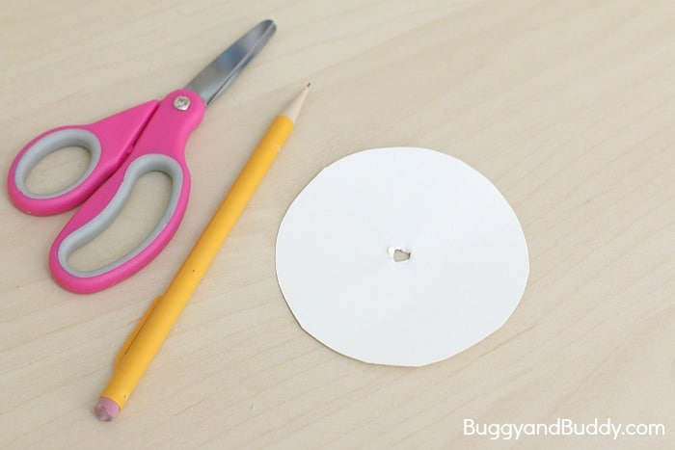
10. Decorate the circle using markers, stickers, crayons etc. Try out different designs, shapes, and letters!

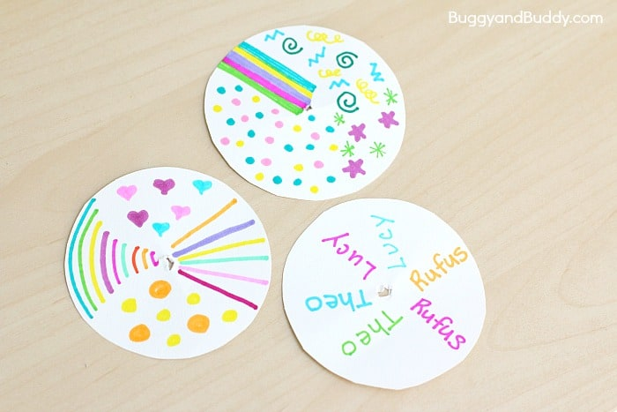
11. Place the circle onto your straw with the design facing the kaleidoscope. You want the hole to fit over the flexible portion of the straw so it will turn easily.
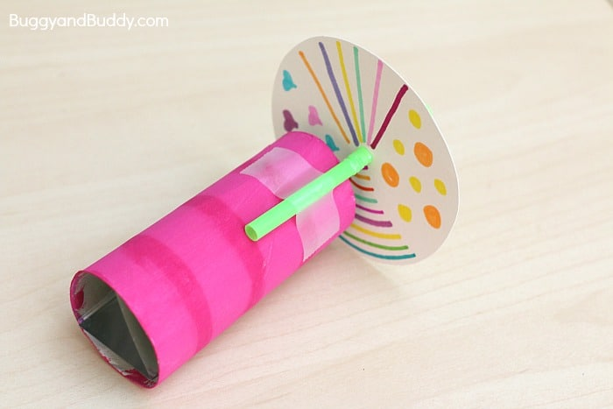
12. Look into your kaleidoscope and explore all the reflections created by your design! 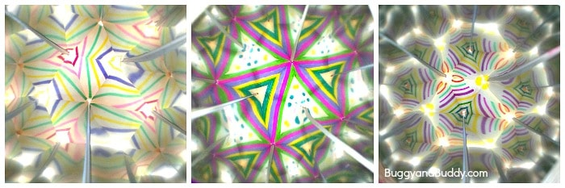

Here are some links to other websites with great ideas for more light experiments:
https://buggyandbuddy.com/light-experiments-for-kids/
https://www.optics4kids.org/classroom-activities/5-10

