Art inspired by nature
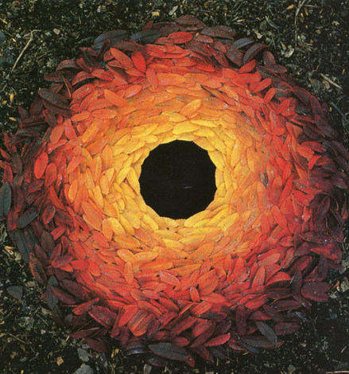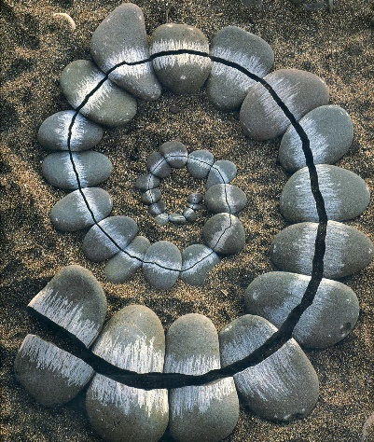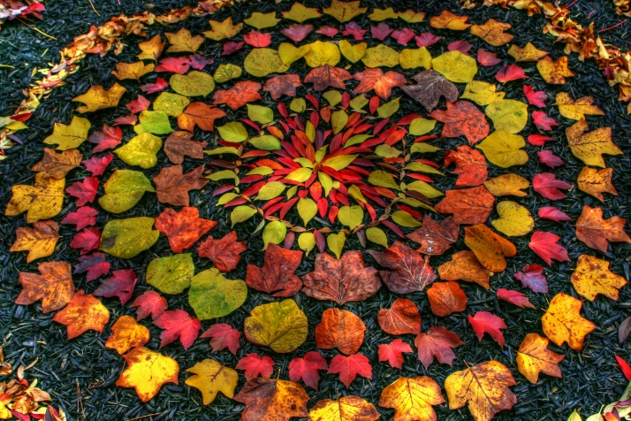
Andy Goldsworthy is a British artist who uses objects from nature to make art. He focuses on colour and shape to create patterns, often in a circle or spiral. Much of his art is made outdoors and is temporary, it will get blown or washed away the next day. He captures his art by taking a photograph of it from above to allow us to see the pattern, colours and shapes.
Your task
Can you create your own art work inspired by nature?
- Go out in your garden or outside space at home and collect natural objects. Look for objects like leaves, stones, sticks, petals, seeds or even blades of grass. Choose objects with different colours
- Arrange them in a pattern or shapes. You could use a circle, spiral, line or other shape you want to try
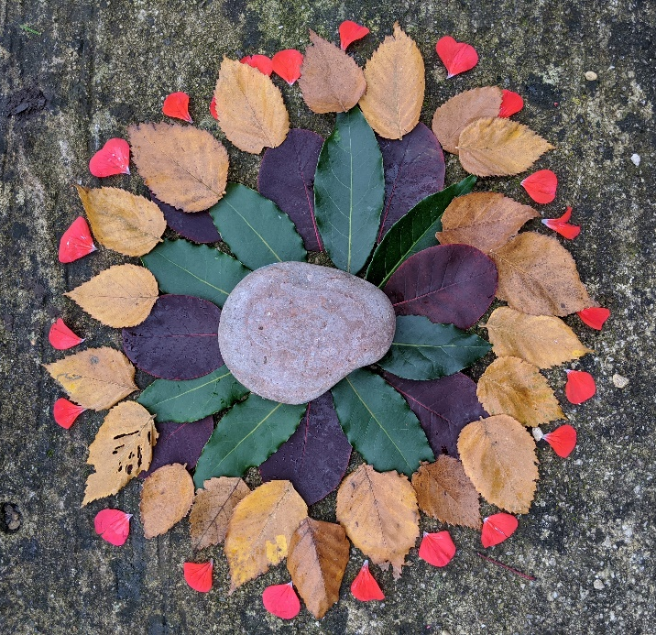
- Take a photo of your art work and email it for Miss Hake to see.

Here’s one I created at home using different coloured leaves and petals as an idea of what you could do.

Don’t have an outside space at home? Don’t worry! Use the leaf outlines below to help you cut leaves out of coloured paper. You could use old magazines or newspapers to get different colours, or paint or colour in your own.



