

Year Group……3/4…… Topic……………Natural Disasters………………..

Learning in Other Subjects




The location of North and South America
Comparison of the climate and temperatures in the UK with key areas of North and South America
Locations and dates of significant natural disasters
How the Earth’s composition is linked to natural disasters
The causes of natural disasters – earthquakes, volcanoes, flooding
Effects of natural disasters on environment and population

Maths: Multiplication and Division, Statistics, Fractions and Decimals and Measures
Science: Rocks and Soils
Computing: Creating Podcasts and Programming
REAL PE: Real Gym (Cognitive and Physical), Athletics/striking and fielding and Swimming (Y3/4)
RE: What do different people believe about God and Salvation
HeartSmart: Don’t hold on to what’s wrong and Fake is a mistake
DT: Electrical circuits – design and make a torch
Art: Painting based on Jackson Pollock
Music: Combining elements to make music
MFL: Vocabulary and conversation about school

English: Poetry, narratives based on Escape from Pompeii and Iron Man and Play Scripts

Previous Learning Links

Location
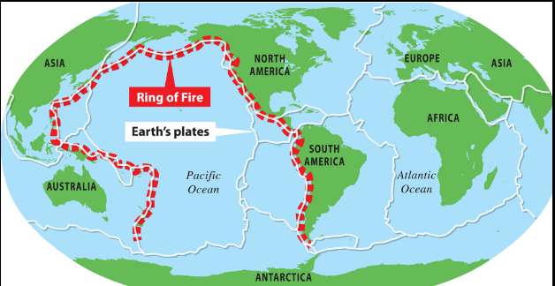
Essential Knowledge

- Names and locations of continents and oceans

- Understanding of climate and weather

- Understanding of seasonal changes

- Understanding of the geographical similarities and differences in key countries around the world


- No history topic this term.
- core
- crust
- dormant
- fault lines
- lava
- magma
- mantle
- molten
- tectonic plates
- vent
Talk like a Geographer
Talk like a Historian
Photos and
Enrichment


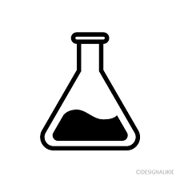


Iron Man
- brink
- gasping
- stupendous
- twilight
- unfurled
- draped
- astounded
- sprawled
Escape from Pompeii
- haggling
- grumble
- stumble
- weave
- strutting
- churn
- quivered
- frantically
- Manmade
- Natural
- Igneous rock
- Sedimentary rock
- Metamorphic rock
- Erosion
- Decomposed
- Durability
- permeability
x axis y axis
bar chart time table
pictogram fraction
numerator denominator tenths
hundredths equivalent
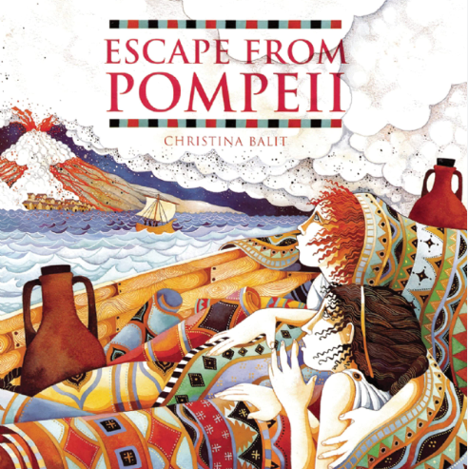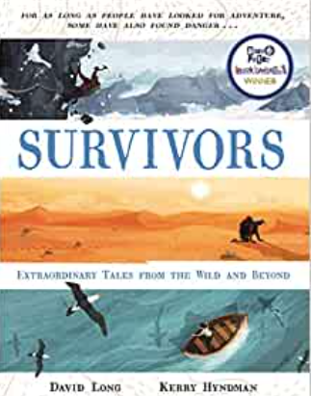
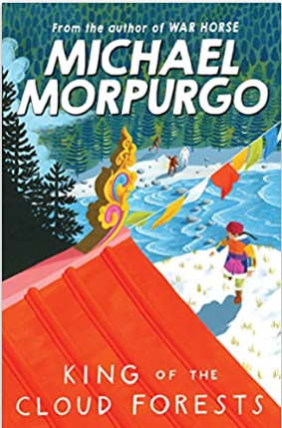
Talk like an Author
Talk like a Scientist

Escape from Pompeii by Christina Balit
King of Cloud Forests by Michael Morpurgo
Survivors by David Long
Quality Texts
Talk like a Mathematician
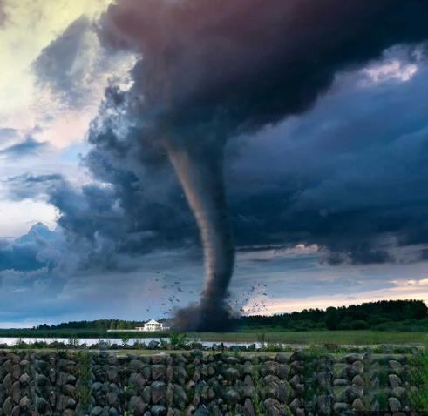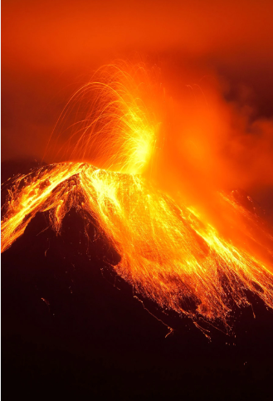
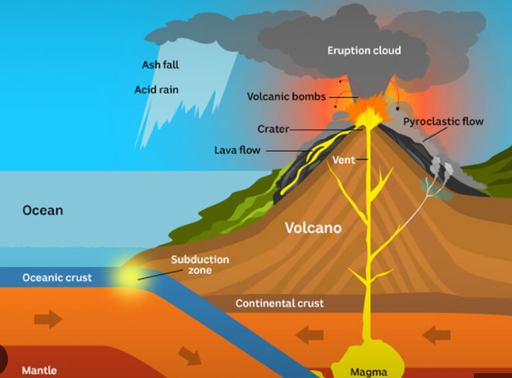
Useful websites to explore:
https://kids.wng.org/node/3222
https://www.bbc.co.uk/bitesize/topics/z849q6f
https://www.natgeokids.com/uk/tag/natural-hazards-and-disasters/
https://kids.britannica.com/kids/article/natural-disasters/609706

