

Year Group……3/4…… Topic……………Ancient Egyptians………………..

Learning in Other Subjects

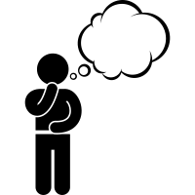


English: Narrative based on Egyptian Cinderella, Poetry and Newspaper Reports

When the Ancient Egyptian civilisation began and ended

The greatest achievements of the Ancient Egyptians

How artefacts can be used to give information about life in Ancient Egypt

What Egyptian life was like for different groups of people

How Ancient Egyptian society has had an impact on modern society and the legacy it has left

Types of settlement and land use at the time

The importance of The Nile to the civilisation.
Previous Learning Links

Maths: Number and Place Value, Addition and Subtraction and Multiplication and Division
Science: Light & Shadows and Forces & Magnets
Computing: PowerPoints
REAL PE: Unit 1 (Personal), Unit 2 (Social) and Dance
RE: Trinity and People of God
HeartSmart: Get HeartSmart and Too Much Selfie Isn’t Healthy
DT: Design, make and evaluate a shaduf
Art: Drawing (Alaa Awad and Eduardo Kobra)
Music: Y3&4 – Developing notation
Y4 – In addition, they will be learning to play the ukulele
MFL: All about me (Moi!) and ‘sticky knowledge’ (revisiting previous learning)
Timeline
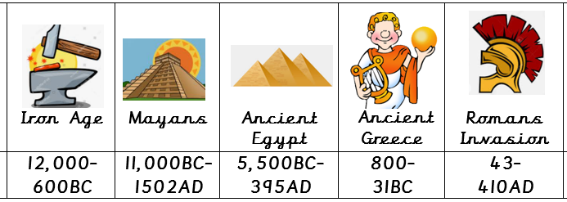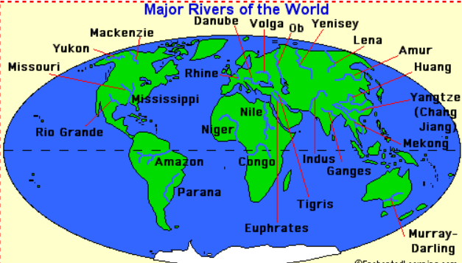
Essential Knowledge

- Names and locations of continents and oceans

- Understanding that life existed a long time ago

- Understanding that there are similarities and differences between life now and life in the past

- Ability to find Africa on a world map

- Egypt
- Africa
- River Nile
- pyramids
- archaeologist
- Howard Carter
Talk like a Geographer
- Ancient
- B.C.
- civilization
- pharaohs
- Sphinx
- sarcophagus
- hieroglyphics
- mummification
- cartouche
Talk like a Historian
Photos and
Enrichment


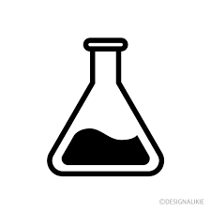
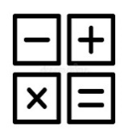

- Attract
- Repel
- Positive
- Negative
- Friction
- Push
- Pull
- Resistance
- Poles
- Magnetic
- Transparent
- Translucent
- Opaque
- Reflection
- Refraction
- Source
- Shadows
Talk like an Author
- tunic
- murmured
- heed
- flocked
- determined
- summoned
- barge
- blared
- cramped
- wearily
- peering
- gawked
- servant
- glowed
- doze
- seldom
- coaxed
- companion
- scarcely
- nimble
- dainty
- clumsy
- splattered
- polished
Talk like a Scientist
- Divide
- share equally
- multiply
- product
- inverse
- factors
- factor pairs
- commutative law

- gods
- deities
- Canopic jars
- settlers/settlement
- afterlife
- artefacts
- culture
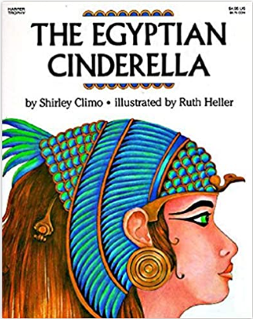
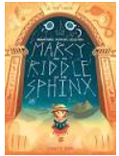
The Egyptian Cinderella by Shirley Climo
Marcey and the Riddle of the Sphinx by Joe Todd-Stanton
Secrets of a Sun King by Emma Carroll
Quality Texts
Talk like a Mathematician
- digit
- partition
- thousands
- hundreds
- tens
- ones
- ascending
- descending
- increase
- decrease
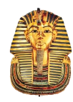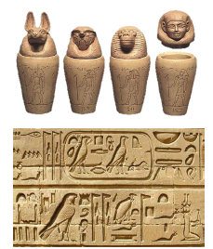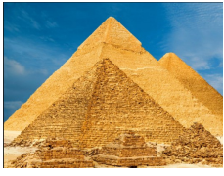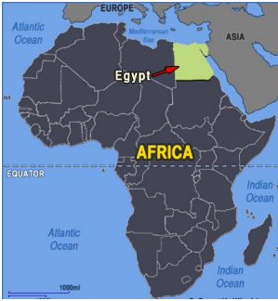
Useful websites to explore:
https://www.bbc.co.uk/bitesize/topics/zg87xnb
http://www.primaryhomeworkhelp.co.uk/Egypt.html
https://kids.britannica.com/kids/article/Ancient-Egypt/353087
https://www.natgeokids.com/uk/discover/history/egypt/ten-facts-about-ancient-egypt/
https://www.historyforkids.net/ancient-egypt.html

