

Year Group……3/4…… Topic……………Stone Age to Iron Age………………..

Learning in Other Subjects




English:

When the Stone Age and Iron Ages began and ended

How we can use artefacts to find out about life in the past.

How artefacts can be used to give information about life in Ancient Egypt

How life changed during the Stone and Iron Ages

How land was used in different ways and an understanding of different settlements

The impact of farming and fishing and the distribution of resources during the Stone and Iron Ages.
Previous Learning Links

Maths: Calculations, mass/volume/capacity & time
Science: Plants
Computing: Scratch
REAL PE: Cricket; coordination, agility and balance
RE: Prayer
HeartSmart: Don’t forget to let love in
DT: Cooking and comparing a modern-day diet
Art: sculpture based on Barbara Hepworth
Music: Raise the Roof singing festival
MFL: Growing Things and All Aboard
Timeline
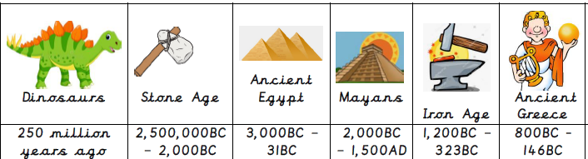
Essential Knowledge

- An understanding that life existed a long time ago.

An understanding of other civilisations, such as the Egyptians.

Name and locate the different countries within the United Kingdom

Knowledge of artefacts that were important in other eras.


Talk like a Geographer
Talk like a Historian
Photos and
Enrichment


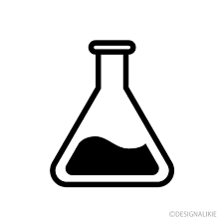


- grams
- kilograms
- millilitres
- litres
- millimetres
- centimetres
- metres
- kilometres
- wandering
- stumbled
- wriggling
- munching
- yelling
- celebrate
- flickering
- furious
- Fertilisation
- Germination
- Seed
dispersal
- Seed
formation
- Sensitivity
- Excretion
- Nutrition
- Pollination

- Mesolithic
- Neanderthal
- Settlement
- civilisation
- bronze
- flint
- iron
- Neolithic
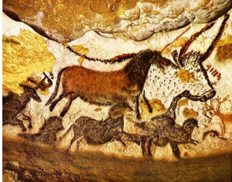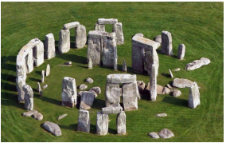
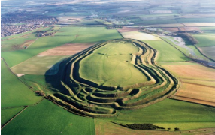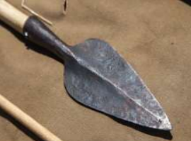
Useful websites to explore:
https://www.dkfindout.com/uk/history/iron-age/
https://www.history.org.uk/primary/categories/the-stone-age-to-the-iron-age
https://www.funkidslive.com/learn/top-10-facts/top-10-facts-about-the-stone-age/#:~:text=The%20Stone%20Age%20is%20a,and%20the%20use%20of%20tools.
https://superbrainybeans.com/history/stone-age/

Talk like an Author
Talk like a Scientist
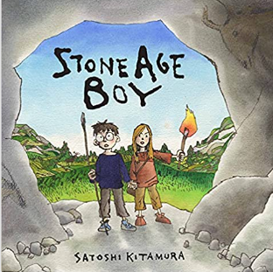
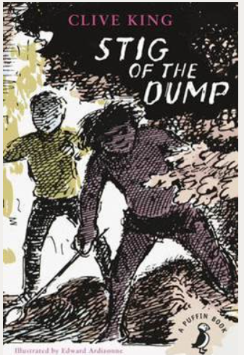
Stone Age Boy by Satoshi Kitamura

Stig of the Dump by Clive King.
Quality Texts
Talk like a Mathematician

