

Year Group……3/4…… Topic……………Invasion…………………………..

Learning in Other Subjects




Previous Learning Links

Maths: Fractions, money, time, shape and statistics
Science: Living things and Food Chains & Digestive System and Teeth
Computing: Word Processing and Connecting Computers (networks)
REAL PE: Cricket; coordination, agility and balance
RE: Gospel and Life is Like a Journey
HeartSmart: Don’t Hold on to What is Wrong and Too Much Selfie Isn’t Healthy
DT: Sewing cushions
Art: Drawing based on Peter Randall-Page
Music: Expression and Improvisation & Singing and Performance
MFL: All Aboard and Going Shopping

English: Non-Chronological reports, persuasive texts, narrative based on Beowulf and poetry
Timeline
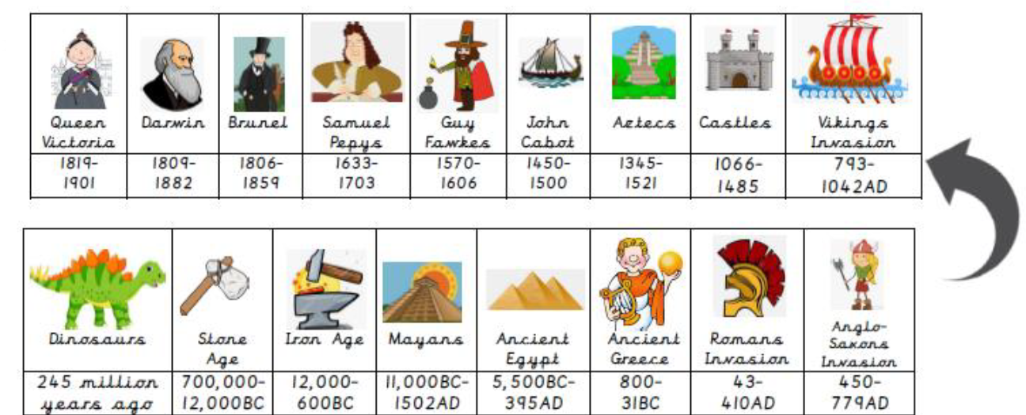
Britain’s settlement by Anglo-Saxons and Scots

The Viking and Anglo-Saxon struggle for the Kingdom of England to the time of Edward the Confessor

Democracy, Government and Rule of Law

Types of settlement – human activity

Oceans and Continents (Europe)

UK Counties and Regions

Essential Knowledge
That life existed a long time ago

The countries of modern-day Britain

The Oceans and Continents

The names of some European countries


Photos and
Enrichment

Talk like a Geographer
Talk like a Historian
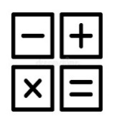

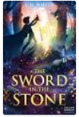




pound second edge angle
pence analogue parallel
coin digital perpendicular
hour vertices horizontal
minute face vertical
gruesome shrieked
craggy towered
shuddered slithered
lair vicious
classification food chain stomach
vertebrates incisors small intestine
environment canines large intestine
habitat molars
producers wisdom
predators decay
conquer myth
Danelaw settle
invasion runes
legend
longship
Quality Texts
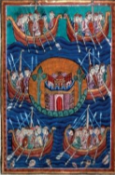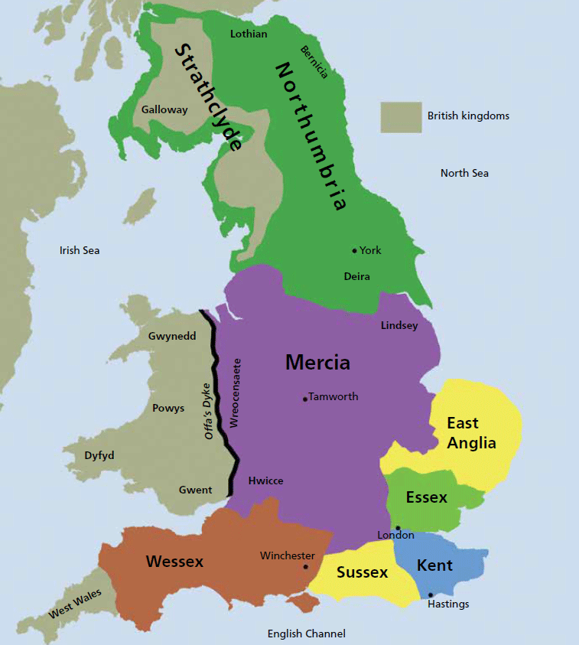
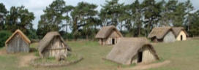
Useful websites to explore:
https://www.bl.uk/anglo-saxons/articles/who-were-the-anglo-saxons
https://www.bbc.co.uk/bitesize/topics/zxsbcdm/articles/zqrc9j6
https://www.history.org.uk/primary/resource/3867/the-vikings-in-britain-a-brief-history
Wolf Brother by Michelle Paver

Beowulf by Michael Morpurgo

The Sword in the Stone by T. H. White
Talk like an Author
Talk like a Scientist
Talk like a Mathematician

