

Year Group……3/4… Topic….The Legacy of the Roman Empire…

Learning in Other Subjects




The impact the Roman Empire had on Britain in the past

The impact that the Roman Empire still has on Britain today

Significant people (Caesar, Boudicca)

Democracy, Government and Rule of Law

Types of settlement – human activity

Oceans and Continents (Europe)

UK Counties and Regions

Previous Learning Links

Maths: Multiplication and Division, Statistics, Fractions and Decimals and Measures
Science: Sound and Electricity
Computing: Create algorithms, debug programs and use a variety of programming software
REAL PE: Cognitive and Creative, Gymnastics, REAL Dance.
RE: What can we learn from religions about deciding what is right and wrong and the kingdom of God on Earth
HeartSmart: No way through isn’t true
DT: Plan, design, build and test a Roman Catapult
Art: Printing mosaic using wood and making clay tiles
Music: Composing and performing with a focus on pitch and melody
MFL: Language linked to animals and pocket money.
English: Instruction Texts, Narrative based on Wolves in the Wall, Instruction Texts and Playscripts

Timeline
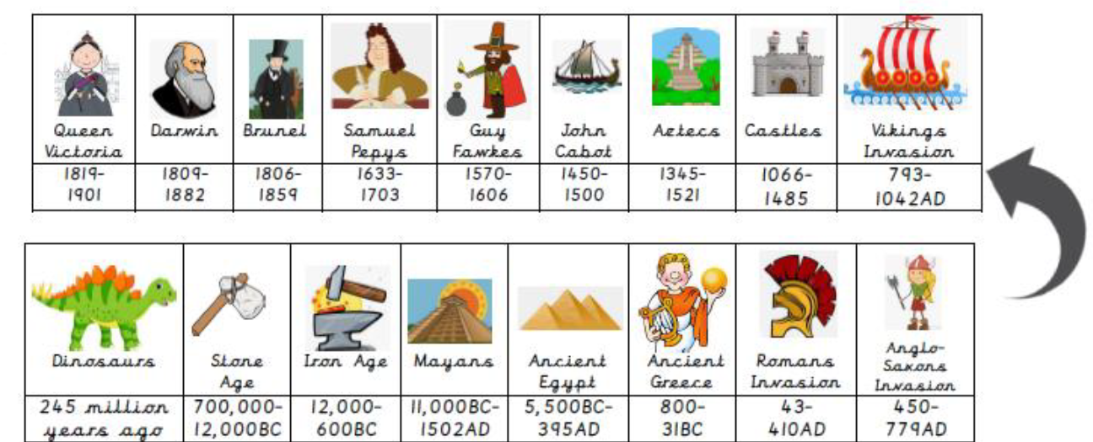
Essential Knowledge
That life existed a long time ago

The countries of modern-day Britain

The Oceans and Continents

The names of some European countries


Photos and
Enrichment

Talk like a Geographer
Talk like a Historian
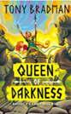
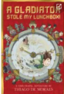





hustling
bustling
gnawing
overactive
ignorance
treasured
astonishingly
brandishing

rural
governor
slyly
reigned
distressed
clenched
flushed
casually

numerator
denominator
grams
kilograms
millilitres
litres
capacity
volume
times
multiply
product
divide
share
metres
centimetres
millimetres

Circuit
Bulb
Wire
Switch
Bell
Battery
Conductor
Cell
Insulator

vibration
volume
pitch
sound waves
tone
frequency
source
insulation
conflict civilisation
empire invasion
legacy parliament
settlement
Quality Texts

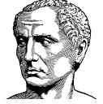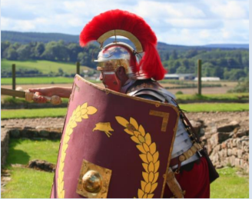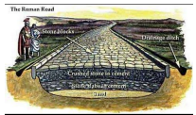
Useful websites to explore:
https://www.bbc.co.uk/bitesize/topics/zxsbcdm/articles/zqrc9j6
https://www.bbc.co.uk/bitesize/topics/zwmpfg8
http://www.primaryhomeworkhelp.co.uk/Romans.html

A Gladiator Stole My Lunchbox by Thiago de Mores
Queen of Darkness by Tony Bradman
Empire’s End: A Roman Story
Talk like an Author
Talk like a Scientist
Talk like a Mathematician

