Monday
Time
Warm up
- Number splat https://www.topmarks.co.uk/learning-to-count/paint-the-squares
- Clap and count numbers both forwards and backwards.
Activities

Explain that we are learning how to tell the time!
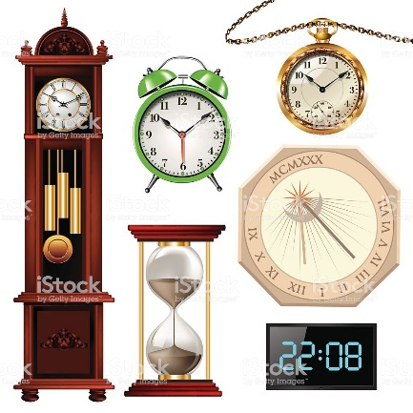
Look around the house for places where it shows us the time e.g. clocks, watches, TV, oven, microwave, radio. Compare differences. They should notice that a clock/watch has 12 numbers and the hands move. Explain that the digital clock is 24 hours. This week we will focus on the 12 hour clock.

If you have a large clock or a watch, use this to model/show the hours on the clock face. Counting 1 o’clock, 2 o’clock and so on. Show how the bigger hand stays at 12 and the smaller hand moves around to tell us the hour. When ready, show ‘half past’ by moving the big hand down to 6.

You could make a large clock to practise this on:

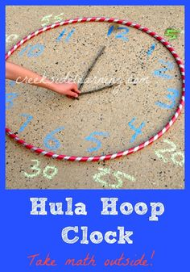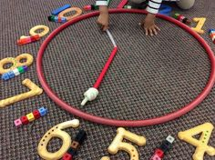

Finish by playing ‘What’s the time Mr Wolf!’

