Monday
Counting in twos
Warm up
- Counting shoes
- Sing the counting in twos song https://www.youtube.com/watch?v=GvTcpfSnOMQ
Activities

Explain that we are learning to count in twos! Lots of things come in pairs e.g. 2 socks, 2 eyes, 2 hands. Can you think of any more examples?

Find 10 objects to practise counting in twos (socks are great, or you could use fruit, lego, cups etc)

Organise the objects into a line and ask your child to count each one e.g. 1, 2, 3, 4 etc. How many are there altogether? Make a number card to place in front, showing 1 -10.
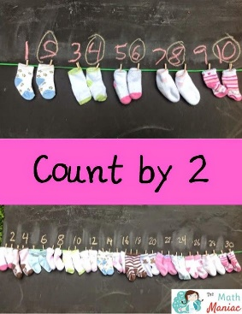
Now, remove the numbers 1, 3, 5, 7, 9. Model counting in twos, 2, 4, 6, 8, 10. Explain that these are even numbers. By counting two at a time we can count more quickly! Group the objects into twos to show this.
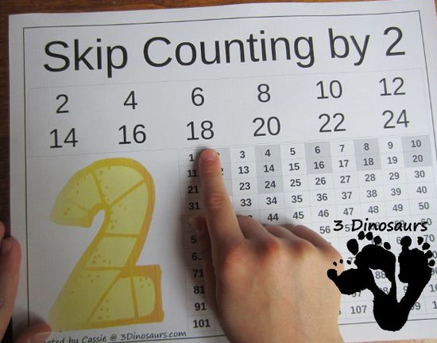
Practise clapping in twos to make a rhythm 2, 4, 6, 8, 10.
*You could also use a number grid to highlight the 2x table

