Wednesday
Odd and Even numbers
Warm up
- Practise jumping and counting forwards and backwards. Roll a dice and say the number.
- Watch the Odds and Evens Number blocks video https://www.bbc.co.uk/iplayer/episode/b08r2l4d/numberblocks-series-2-odds-and-evens
Activities

Explain that numbers can either be ‘odd’ or ‘even’. All the numbers in the 2x table are even! Use the splat square and highlight the even nubers. Point out that they all end in 0,2,4,6 or 8! Next, highlight the odd numbers. These all end in 1,3,5,7 or 9.
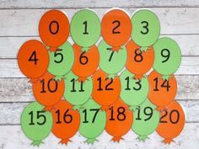
When you go on your daily walk, look at the house numbers. They are normally odds on one side and evens on the other. Can you count them?

Print or make a number line to 20. You can choose one colour for odd and another colour for even. Colour in the numbers and practise counting in odds and evens!

Next, hide numbers around the room. Race to see how many you can pick up in one minute, but remember: only even numbers! You get a point for every even number but lose a point if you accidently picked an odd one.
Finish by making an odds and evens paper chain
