YEAR 1 HOME LEARNING
WRITING  Go to www.pobble365.com. Complete daily work for each picture on there. I would love you to share your writing that you produce – be imaginative! | Dear Parents,  As a school, we have put together a mix of both academic and creative learning to keep the children engaged during the next two weeks of potential school closure. This will be a great opportunity for you to learn alongside your children.  As a school, we are fully committed to ensuring that the children keep learning whilst the school is closed. Learning projects will be updated regularly depending on how long the closure lasts. Our next update will be after the Easter holiday if we are still closed. At present, we have provided plenty of suggested learning for you to undertake.  Please look out for updates on the school website and the class pages. This is where links for work and projects will be posted.  Happy learning in your family environment, stay safe and well.  Best wishes  Paul  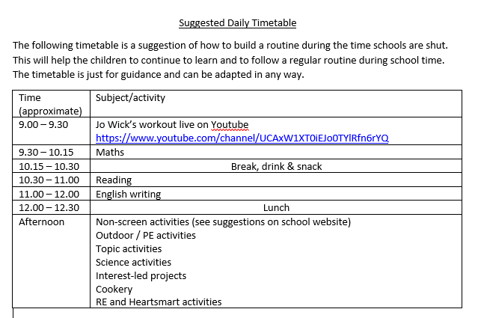 | MATHS  Number bonds  Children in Year 1 and 2 need to know the number bonds to 20. This is the same login as TT Rockstars  https://play.numbots.com/#/account/school-login-type  Times Tables  Children in Year 2 learn the 10, 2 and 5x tables.  Hit The Button. Go online and practise 3x a week.  https://www.topmarks.co.uk/maths-games/hit-the-button  Times Table Rockstars  https://ttrockstars.com/  On the class pages, there are Maths Home Learning Packs which the children can work through
READING COMPREHENSION
There are a number of reading comprehension tasks in your pack to work on. Please complete two a week.
DAILY READING
There is still an expectation that children will read at least four times a week and fill in their journals. This is a great opportunity to read some good books.
Additional books can be found at
https://www.oxfordowl.co.uk/
https://www.getepic.com/

SCIENCE  Our next topic in science is plants.  Go on a walk of your local area and identify the trees that you see using the tree identification sheet. (This can be found on the class page)  Go on a wild plant hunt and record your findings in the tally chart. (This can be found on the class page)  Plant the seeds sent home and complete the dairy of how they grow. (You could take photos.)  Draw a map of your garden showing the plants. Draw a map of a garden you would like. | TOPIC/ CREATIVE  Research and create a leaflet or poster about a country of your choice.  You could include a map, flag land use, language spoken, famous residents, famous landmarks and places to visit etc.  Find out about the artist Mondrain and look at his pictures.  https://www.tate.org.uk/kids/explore/who-is/who-piet-mondrian  Then create a Mondrian heart of your own using the materials of your choice.  https://www.artycraftykids.com/art/mondrian-heart-art-for-kids/ | PHONICS  Please practice phonics and common exceptional words daily.  There are phonics words and the common exception word lists on the class page  A phonic website with fun games is  https://www.phonicsplay.co.uk/  This is free at the moment with the following:
 | ONLINE VIDEO HELP:  MATHS: www.bbc.co.uk/bitesize/subjects/z826n39 has lots of guides to help you.  SPAG: www.bbc.co.uk/bitesize/topics/zwwp8mn (grammar)  www.bbc.co.uk/bitesize/topics/zvwwxnb (punctuation)  SCIENCE: www.bbc.co.uk/bitesize/topics/zrffr82/articles/zppvv4j | PE  Joe Wicks Workouts  www.youtube.com/watch?v=d3LPrhI0v-w  Cosmic yoga  https://www.cosmickids.com/category/watch/  Super mover  https://www.bbc.co.uk/teach/supermovers

