Thursday
Money
Warm up
- Running and jumping whilst counting forwards/backwards to 20 and beyond.
- Toy shop money game https://www.topmarks.co.uk/money/toy-shop-money
Activities
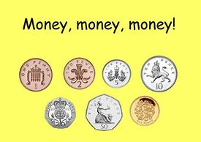
Recap the coin values from yesterday’s home learning. Play a quick game of ‘splat the coin’ e.g. find 2p, find 5p.

Next, explain you are going to make a special shop. You could use toys/fruit/household objects to sell. Use paper to make a price tag for each object (e.g. teddy 10p). Pretend to select 2 items from the ‘shop’ and record this as an addition e.g. I have 1 teddy that costs 10p and a doll that costs 5p. So I will write 10p + 5p = ? Use coins to add 10 and 5 to find the answer 15p. repeat with different examples of buying items in the shop.

You could even make a banner or sign for the shop e.g. Liam’s Toy Shop. Get into character as the customer and shop keeper and practise fun practical maths addition!

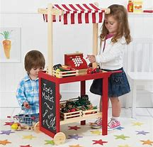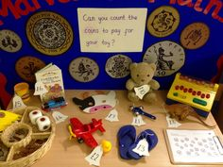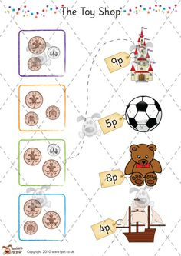

Lots of good resources here: https://www.sparklebox.co.uk/topic/roleplay/shops/toy.html

